

**OPERATING SYSTEM LAB**

**TAYYABA REHMAN 49690**

**LAB 14**

**TASK 1:**

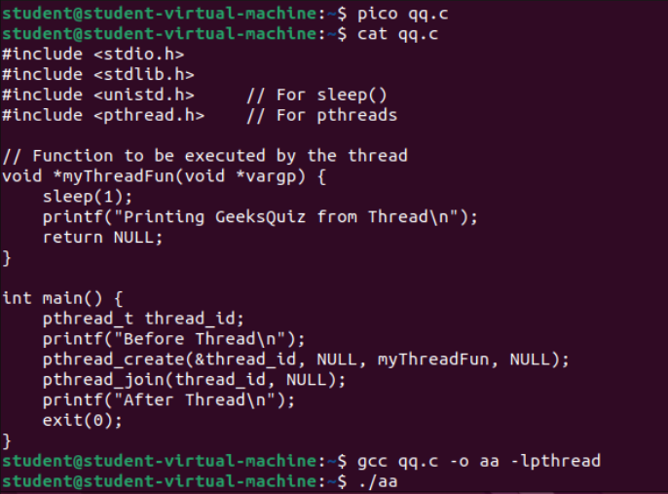

**OUTPUT:**

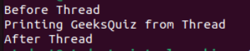

**TASK 2:**

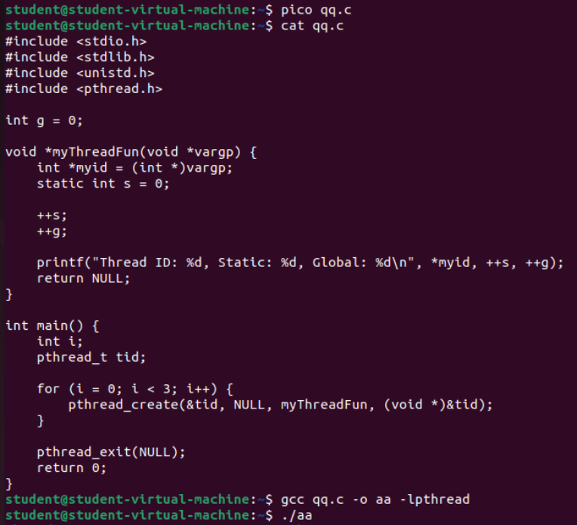

**OUTPUT:**

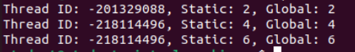

**Explanation:**

This C program demonstrates how to create and run multiple threads using the **pthread** library. It shows how global and static variables behave in a multithreaded environment.

**“g”** is accessible to all threads. When any thread changes it, the change is visible to others. Each thread runs this function. **“s”** is static, so all threads share it.

Every thread increases both **s** and **g** by 1.

In simple words:

pthread_create() starts new threads.

pthread_join() waits for them to finish.

Global and static variables are shared between threads.

**TASK 3:**

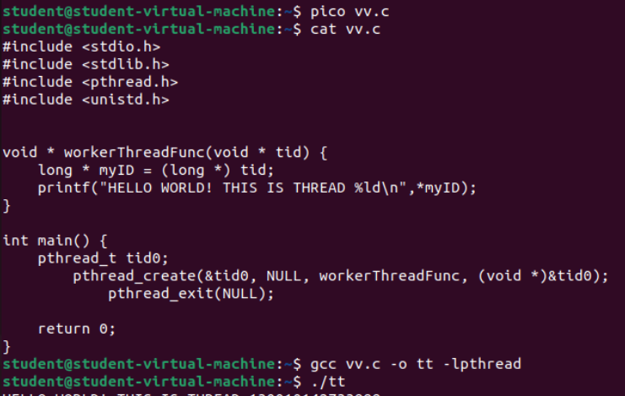

**OUTPUT:**



Modify **pthread_create** and convert into for loop and create three threads and show output. Also removes pthread_exit and see what happens.

**Code:**

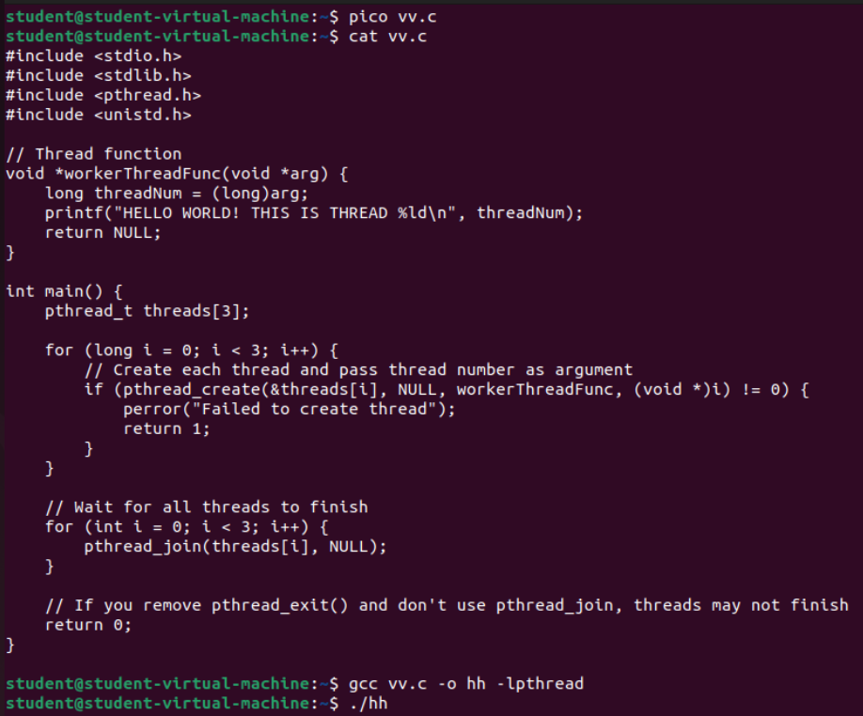

**OUTPUT:**

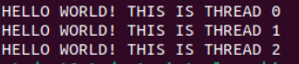

**TASK 4:**

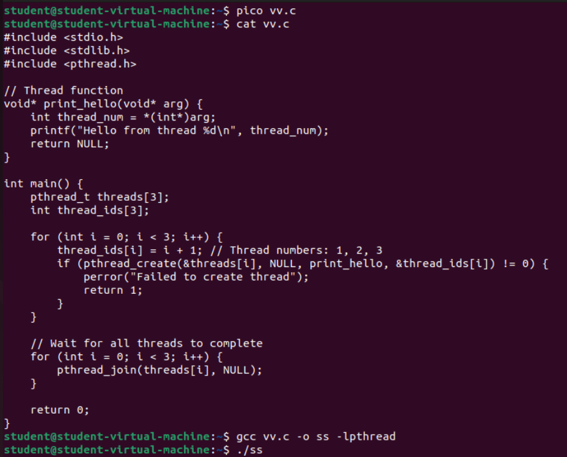

**OUTPUT:**

